# Asset Management Portal— Final Project Report

**1. INTRODUCTION**

**1.1 Project Overview**

The **Asset Management Portal** is a ServiceNow-based solution for efficiently managing physical and digital assets. It enables administrators to track, assign, and maintain assets using a single Asset Inventory table. Key features include automated processes, user-friendly forms, auto-generated asset IDs, and reporting tools. The system improves accuracy, reduces manual work, and supports data-driven decisions through components like UI Actions, and Scheduled Jobs.

**1.2 Purpose**

The primary purpose of this project is to develop a **centralized and automated platform** for managing organizational assets. It aims to replace manual tracking systems, minimize asset mismanagement, improve lifecycle visibility, and enable proactive actions through automation and reporting in ServiceNow.

**2. IDEATION PHASE**

**2.1 Problem Statement**

Many organizations rely on manual methods or disconnected systems to manage their assets, leading to **data inconsistencies, lack of visibility, delayed updates, and inefficient tracking** of asset usage and condition. This results in **asset mismanagement**, increased operational costs, and difficulty in making informed decisions.

**2.2 Empathy Map Canvas**

**Says:**

* "I need a centralized place to view and manage all our assets."
* "It's hard to keep track of asset status and assignments manually."

**Thinks:**

* "Are all our assets being used efficiently?"
* "What if an asset goes missing or isn't maintained on time?"

**Does:**

* Manually updates spreadsheets or basic records.
* Tracks asset usage by checking with teams or physical inventories.

**Feels:**

* Overwhelmed by the complexity of managing numerous assets.
* Frustrated with errors, delays, and lack of visibility in the current system.

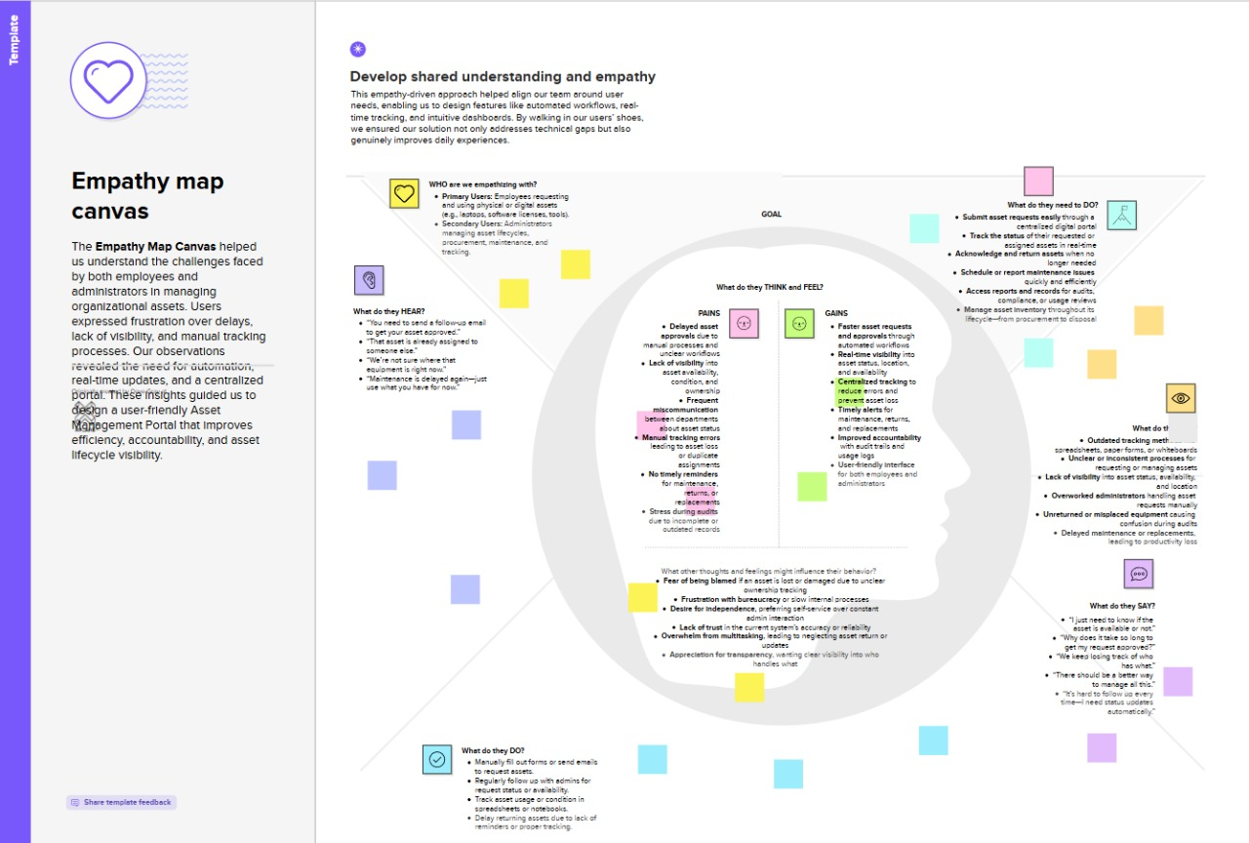

**2.3 Brainstorming**

The team explored ideas such as using a custom ServiceNow table (Asset Inventory) to manage all asset records, configuring auto-numbering with a prefix for easy identification, and implementing UI Actions to streamline asset status updates (e.g., “Mark as Repaired”). Discussions also included setting up scheduled jobs for maintenance alerts, and integrating reports and dashboards for better visibility. The focus was on building a centralized, user-friendly, and scalable system to automate and simplify asset management.

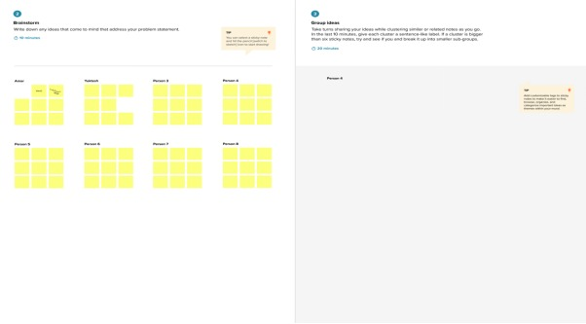

**3. REQUIREMENT ANALYSIS**

### **3.1 Customer Journey Map**

Users create and update asset records, assign them to employees, and track their lifecycle stages such as repair or disposal. The system provides automation for status changes, maintenance alerts, and visual insights through reports and dashboards.

### **3.2 Solution Requirement**

* Single **Asset Inventory** table to manage all asset data
* **UI Actions** for quick lifecycle operations like "Mark as Repaired"
* **Scheduled Jobs** for warranty expiry or maintenance notifications
* **Reporting and Dashboard capability** for asset tracking and performance insights

**3.3 Data Flow Diagram**

The DFD shows data flowing from user forms → validation → storage in tables → automation triggers → reports/alerts generation.

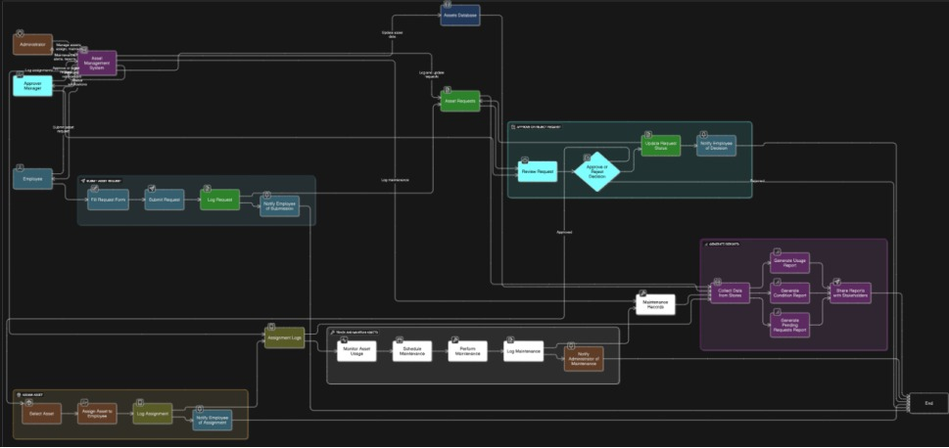

**3.4 Technology Stack**

* ServiceNow Custom Tables and Forms
* Glide API, Business Rules, UI Policies
* ServiceNow Notification Engine
* MySQL Backend (ServiceNow-managed)
* ServiceNow REST APIs (optional for future integrations)

**4. PROJECT DESIGN**

**4.1 Problem–Solution Fit**

The system addresses the challenges of manual and fragmented asset tracking by providing a **centralized platform** for managing all organizational assets. It simplifies the process of recording, assigning, and maintaining assets while automating routine tasks such as status updates and maintenance alerts. With features like auto-generated asset IDs, UI actions, and reporting, the portal ensures improved visibility, accuracy, and control over the entire asset lifecycle.

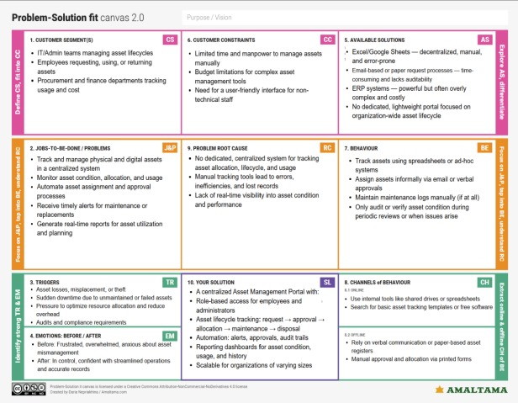

**4.2 Proposed Solution**

A ServiceNow-based tool with:

* Custom tables
* UI Actions
* Scheduled Jobs
* Categorized reports
* Testing UI Actions and Scheduled Job

**4.3 Solution Architecture**

The architecture comprises four layers:

* **Data Layer:** Stores all asset details in a single Asset Inventory table.
* **Logic Layer:** Handles automation via Business Rules, UI Actions, Scheduled Jobs, and Number Maintenance.
* **UI Layer:** Provides user-friendly forms, UI Policies, and related lists for effective interaction.
* **Configuration Layer:** Uses Update Sets for deploying system components and configurations

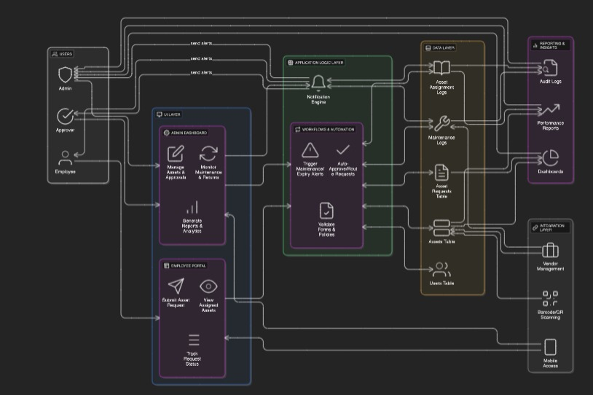

**5. PROJECT PLANNING & SCHEDULING**

**The project was completed over 3 sprints:**

* **Sprint 1:** Instance setup, update set creation, Asset Inventory table setup (8 points)
* **Sprint 2:** Form customization, auto-numbering, business rules, and UI actions (7 points)
* **Sprint 3:** Scheduled jobs, maintenance alert setup, and report/dashboard creation (5 points)

**Velocity: 20 story points / 3 sprints = ~6.67 points per sprint**

The Project was completed as the following milestones covering 3 sprints

The team executed these milestones:

1. ServiceNow Instance Setup
   * Signed up at developer.servicenow.com and requested a Personal Developer Instance (PDI)
   * Filled necessary details; received instance access credentials via email
   * Logged in and prepared the instance for development
2. Creation of Asset Inventory Table
   * Created the Asset Inventory table .
   * Create the following fields:
     1. Assigned to : string
     2. Status : choice
     3. Purchase date : date
     4. Warranty Expire : date
     5. Asset name : string
     6. Type : choice

Number : String

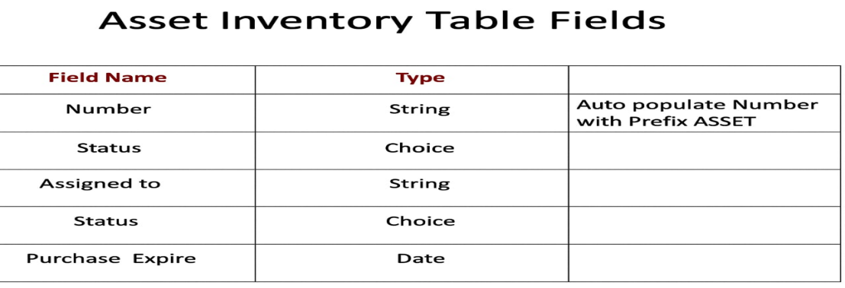

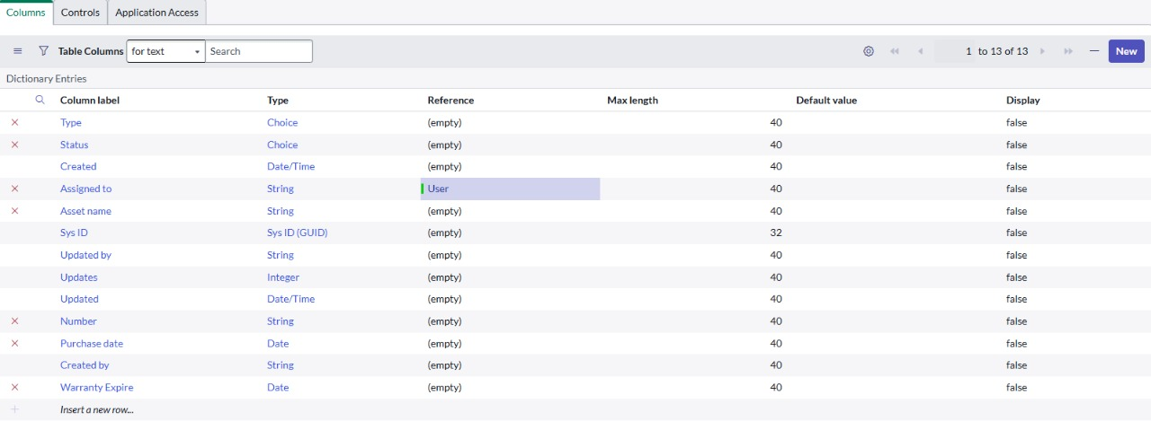

1. Creation of UI Actions
   * The **"Mark As Lost" UI Action** in the Asset Inventory table enables users to update an asset's status to "Lost" with one click.
   * It includes a condition to ensure appropriate visibility and uses a script to automate the update and redirect. .

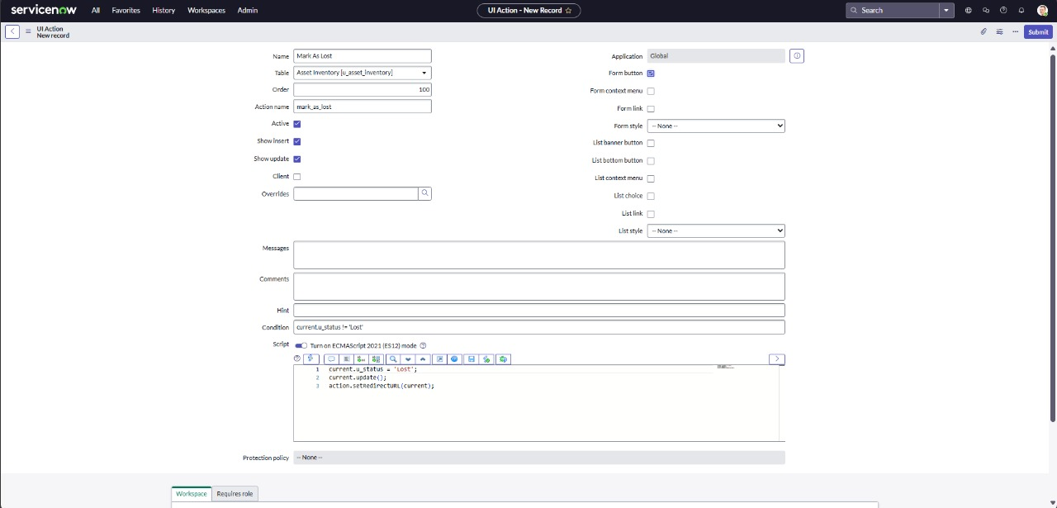

1. Creation of Second UI Action
   * The **"Mark As Repaired" UI Action** was implemented in the Asset Inventory table to simplify restoring asset status.
   * It becomes available when an asset is marked as **Damaged** or **Lost**, allowing users to update its status to **Available** with a single click.

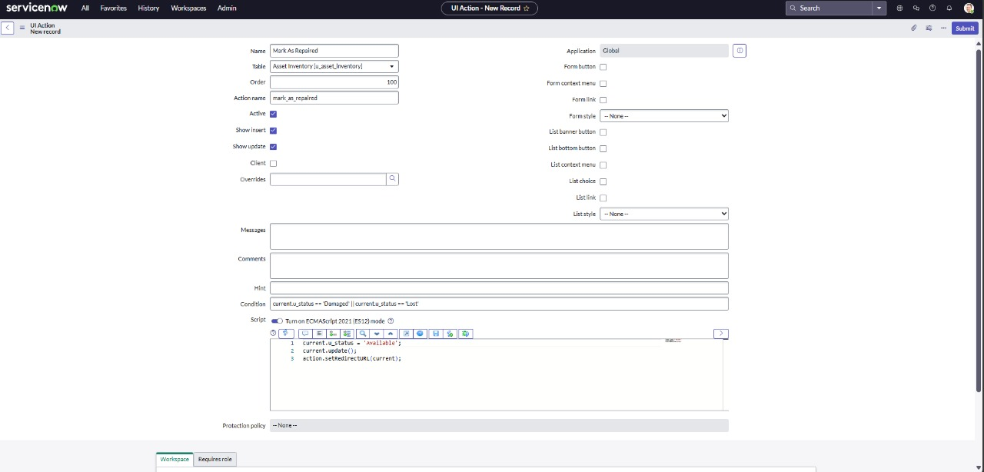

1. Third UI Action Creation

* The **"Mark As Damaged" UI Action** was created in the Asset Inventory table to quickly update an asset’s condition when it is found to be damaged.
* This action is only available if the asset is not already marked as **Damaged**.

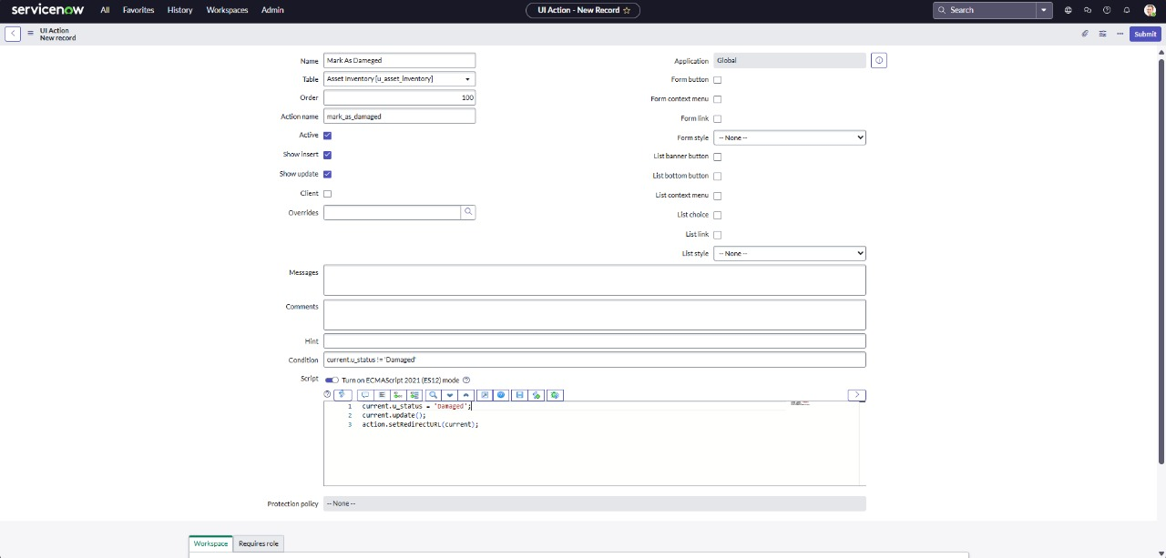

)Creation of Scheduled Jobs

* The **"Warranty Expiry Alert" Scheduled Job** was created to automatically check for assets nearing the end of their warranty period. Configured to run **daily at 12:00 PM**, the job uses a script to identify such assets and can be extended to send notifications or trigger maintenance actions.
* Implemented the logic to manage data consistency or automate actions (actual script written as part of development)

var grAsset = new GlideRecord('u_asset_inventory'); // Replace with your table name

var today = new GlideDateTime();

var futureDate = new GlideDateTime();

futureDate.addDays(30); // Get date 30 days from now

grAsset.addQuery('u_warranty_expire', '<=', futureDate); // Warranty expiring within the next 30 days

grAsset.addQuery('u_warranty_expire', '>=', today); // Warranty expiring after today

grAsset.query();

while (grAsset.next()) {

var email = new GlideEmailOutbound();

email.setSubject("Warranty Expiry Alert: " + grAsset.getValue('u_assest_name')); // Use getValue for dynamic field access

email.setBody("The warranty for " + grAsset.getValue('u_assest_name') + " (Type: " + grAsset.getValue('u_asset_type') +

") is expiring soon on " + grAsset.getValue('u_warranty_expiry') + ". Please take action."); // Get values dynamically

email.setTo('it-support@company.com'); // Change to your IT support email

email.send();

gs.info("Email sent for assest: " + grAsset.getValue('u_assest_name')); // Log for confirmation

}

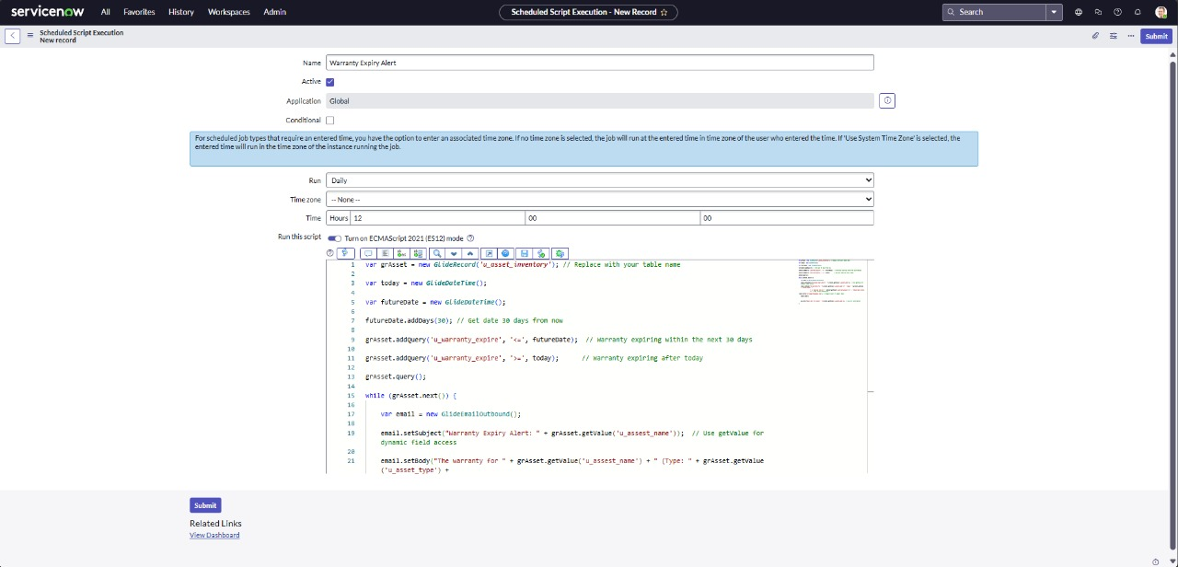

1. Creation of Reports

The **"Available vs Assigned Assets"** report was created in ServiceNow to provide a visual summary of asset distribution based on their status. Using the **Asset Inventory** table as the data source, the report is configured as a **Pie Chart**, grouped by the **Status** field with a **Count** aggregation.

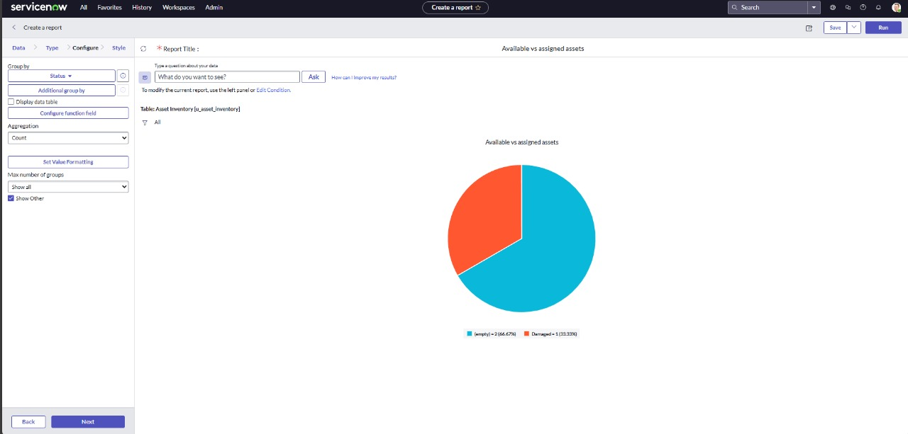

**6. FUNCTIONAL AND PERFORMANCE TESTING**

**6.1 Performance Testing**

The system was tested for:

* Accurate **update of asset status** using UI Actions
* Timely execution of **Scheduled Jobs** for warranty and maintenance alerts
* Proper **form behavior** based on UI Policies (e.g., conditionally visible fields)
* Reliable display of **report data** grouped by asset status
* Efficient loading and updating of **Asset Inventory records**

**7. RESULTS**

**7.1 Output Screenshots**

* Tested UI action.

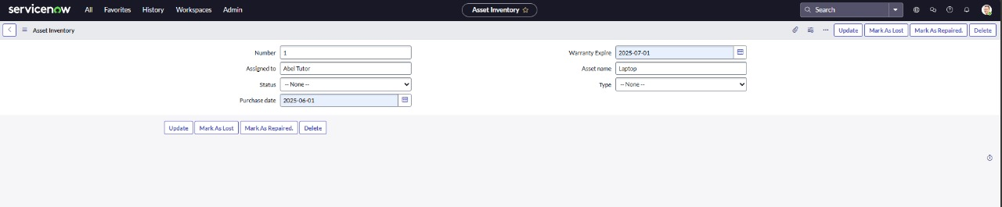

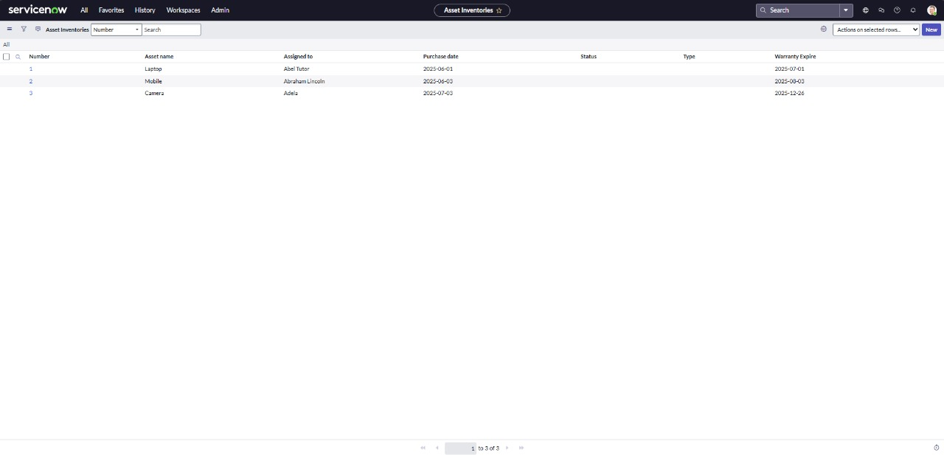

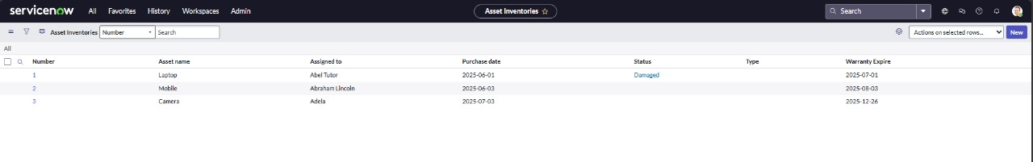

* Tested Scheduling Job.

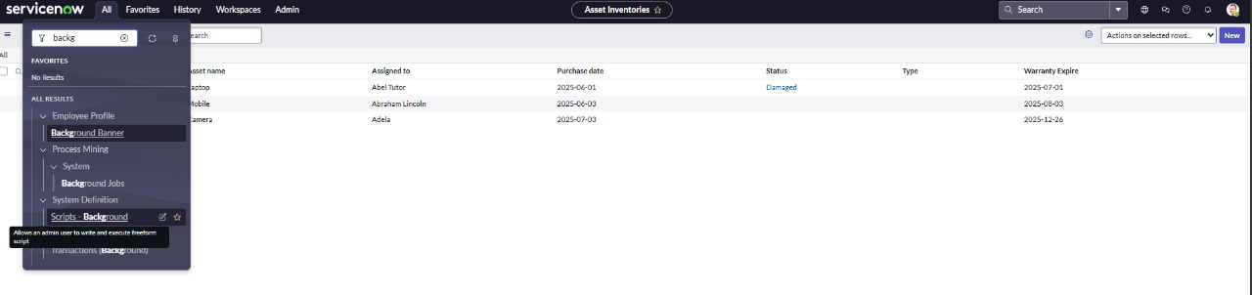

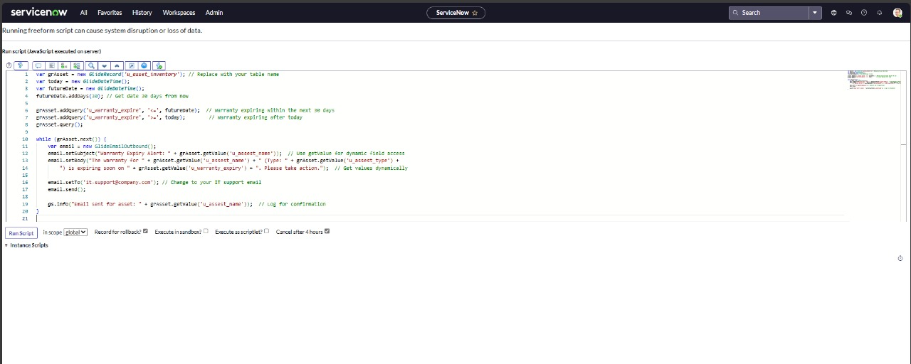

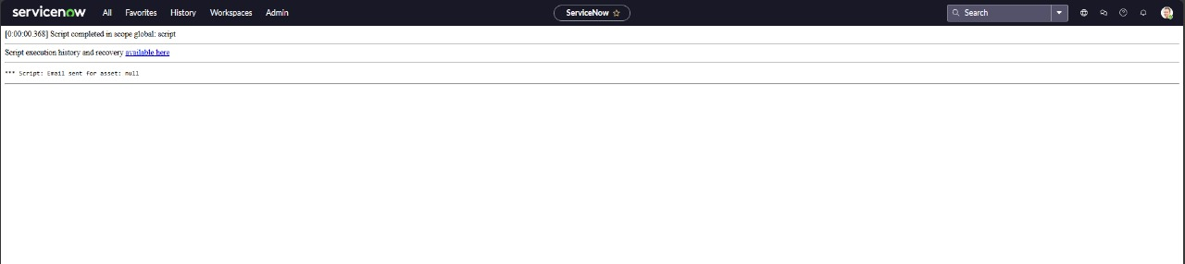

**8. ADVANTAGES & DISADVANTAGES**

**Advantages**

* Centralized, automated expense tracking
* Real-time budget monitoring
* Easy to extend for more features
* Low-code development for rapid deployment

**Disadvantages**

* Requires ServiceNow knowledge for configuration
* Depends on PDI availability or enterprise licensing

**9. CONCLUSION**

The **Asset Management Portal** offers an end-to-end solution for efficient asset tracking and management using ServiceNow. It leverages automation, real-time updates, and reporting to reduce asset downtime, improve accountability, and support data-driven decisions. By streamlining workflows and enhancing visibility, the system helps organizations maximize asset value, reduce costs, and boost productivity.

**10. FUTURE SCOPE**

* Integration with external financial planning tools
* Advanced analytics and dashboards
* Mobile-friendly forms for easier data entry
* Multi-family or community-level expense tracking